VISVESVARAYA TECHNOLOGICAL UNIVERSITY, BELAGAVI.


“Hospital Patient Management System”

Submitted by
Anish Bhandarkar
USN: 2KL19CS007


Under the Guidance of
Staff Incharge
Prof. Savita Bakare
Prof. Keerti Naregal
Prof. Anirudha Potdar
DEPARTMENT OF COMPUTER SCIENCE AND ENGINEERING
KLE DR. M. S. SHESHGIRI COLLEGE OF ENGINEERING & TECHNOLOGY
BELAGAVI – 590 008, KARNATAKA, INDIA
Academic Year 2021-22

KLE DR. M. S. SHESHGIRI COLLEGE OF ENGINEERING & TECHNOLOGY, BELAGAVI-590008

Certificate for Approval of DBMS Mini Project Report

This is to certify that Mr/Ms. Anish Bhandarkar (2KL19CS007) has satisfactorily completed the DBMS mini project on “Hospital Patient Management System” for partial fulfilment of DBMS Lab of V Semester B.E. Computer Science and Engineering of the Visvesvaraya Technological University, Belagavi for the year 2021-2022.

Staff Incharge HOD
Contents:
- Abstract
- Introduction
- Scope and Objectives
- Results snapshot
- Conclusion
- References

Abstract:
Hospital Patient Management System is an organized computerized system designed and programmed to deal with day to day operations and management of the hospital activities. The system can look after patients, records, illness status and treatments by giving a unique id for every patient and storing the details in database. It also maintains hospital information such as wards and doctors in charge.
The Hospital Patient Management System can be entered using a username and password. It is accessible to administrator, manager and doctors of hospital. Only they can add data in to the database. The data can be retrieved easily. The interface is very user-friendly.

Introduction:
The project Hospital Patient Management system includes registration of patients, storing their details into the system, maintaining patient report. The software has the facility to give a unique id for every patient and stores the details of every patient. It includes a search facility to know the details of each patient. This System can be entered using a username and password. It is accessible to administrator or receptionist who does patient registration and stores the details in patient database, manager who has access to all databases and doctor who will maintain patient’s medical record.
Hospital Patient Management System is very easy to use and is designed and developed to deliver the benefits of Systematic operations, Enhanced administration and control, best patient care to hospitals. It reduces lot of paper work needed and handled. Hospital Patient Management System is a software product suite designed to improve the quality and management of hospitals.
Modules:
The entire project consist of 3 main modules, which are
1)Admin module:
- Manages patient registration.
- View registered patient details.
- Search, Update Delete patient details.
2)Doctor module:
- Manages patient record.
- Identifies disorder and accordingly provides medication.
- Search, Update, Delete patient records.
3)Manager module:
- Manages wards and doctors in charge.
- View patient registration details.
- View patient record.

Software Specifications:
1)Python
Python version 3.10.0 is used for creating graphical user interface with the help of tkinter module.
pymysql is used to connect python program to mySQL database
2)mySQL
Used to store the data in the form of tables in database and to perform queries on it.

Fig 1. ER diagram of Patient Hospital Management System:
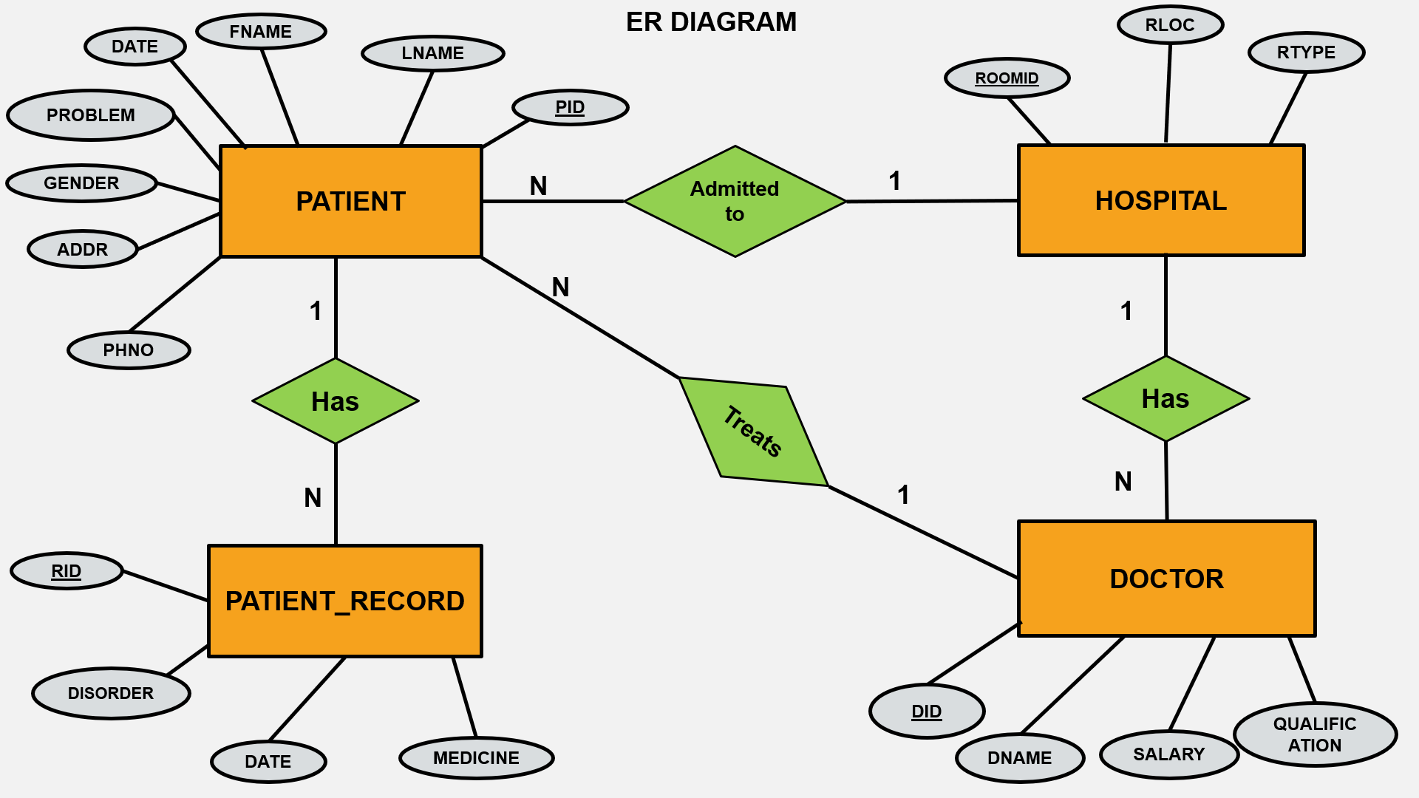

Fig 2. Schema diagram of Patient Hospital Management System:
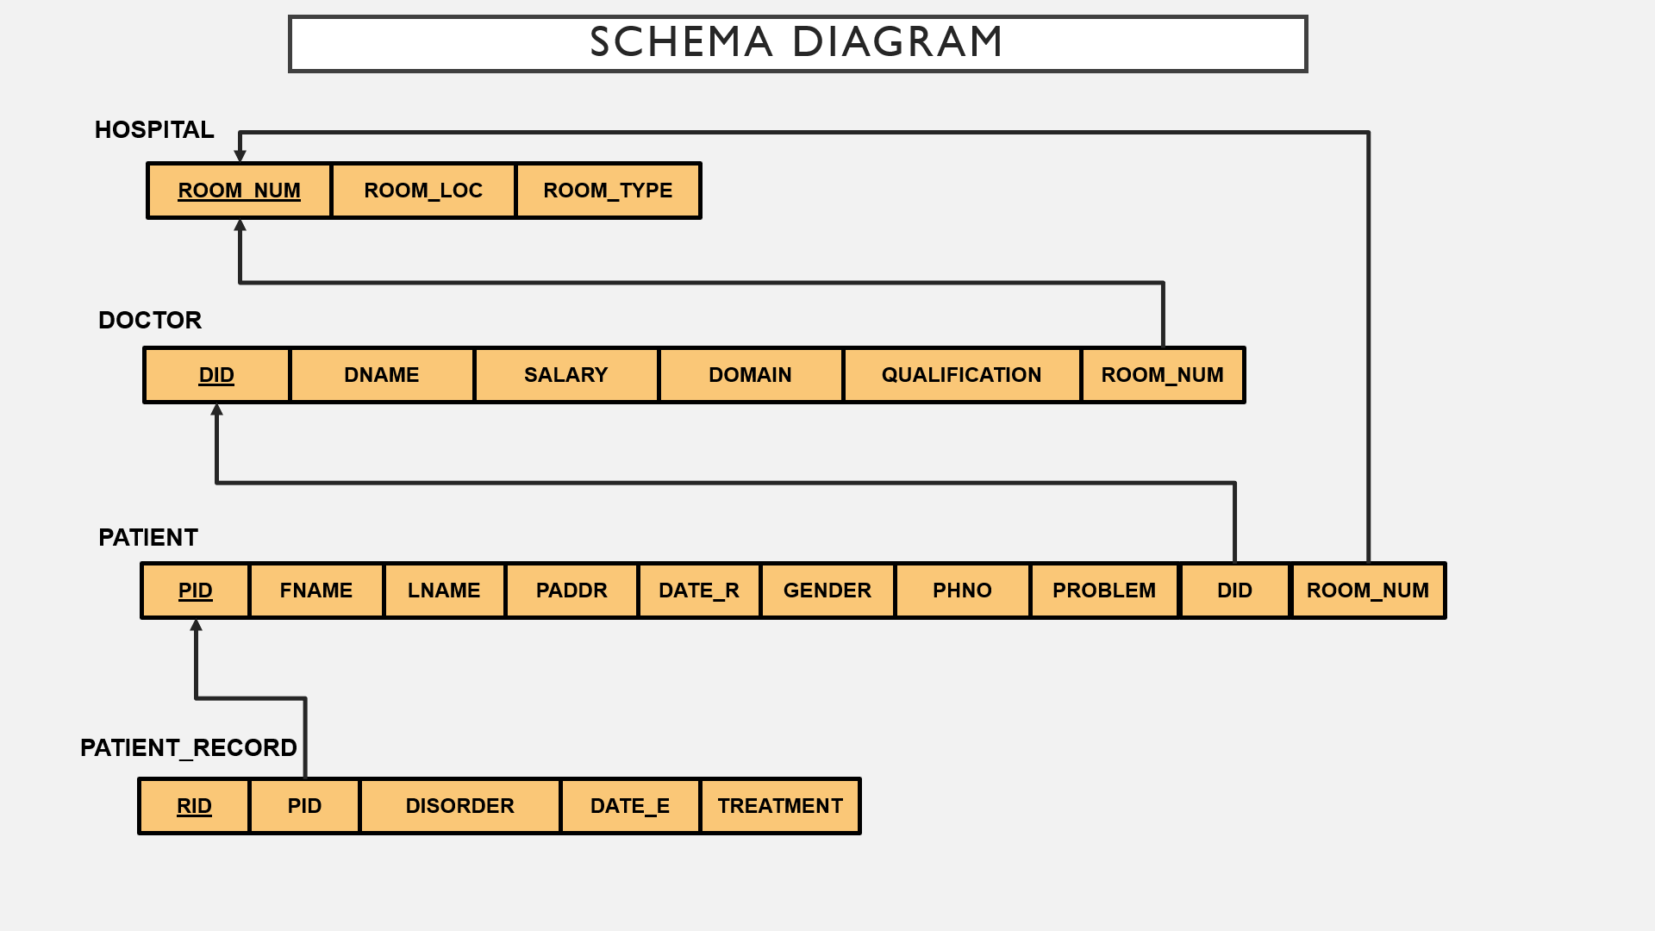
Scope:
Performance:
During past several decades, the hospital management system is supposed to maintain manual handling of all the hospital daily activities. The manual handling of the record is time consuming and highly prone to error. To improve the performance of the patient hospital management system, the computerized patient hospital management system is to be undertaken. The computerized hospital project is fully computerized and user friendly.
Efficiency:
The basic need of the project is efficiency. This project is efficient as, whenever a new patient is admitted, admin registers, a ward is assigned and also a doctor is assigned to the patient according to the patient’s disease.
Control:
The complete control of the project is under the hands of authorized person who has the password to access this project and illegal access is not supposed to deal with. All the control is under the manager who has rights to just see the records of every database.
Security:
Security is the main criteria for the proposed system. Since illegal access may corrupt the database and it will affect not only the hospital but also it also affects the patient's as well as doctor's life. So only authorized people of hospital can access the system.

Objective:
1)Register the patients.
2)According to patient's disease, assigning doctor.
3)Keeping patient's registration details in database.
4)Doctor will identify the disorder and assign medication.
5)keeping patient's medical record in database.
6)Keeping information of wards and doctors in charge.

Results Snapshots:
Fig 1. Hospital Patient Management System
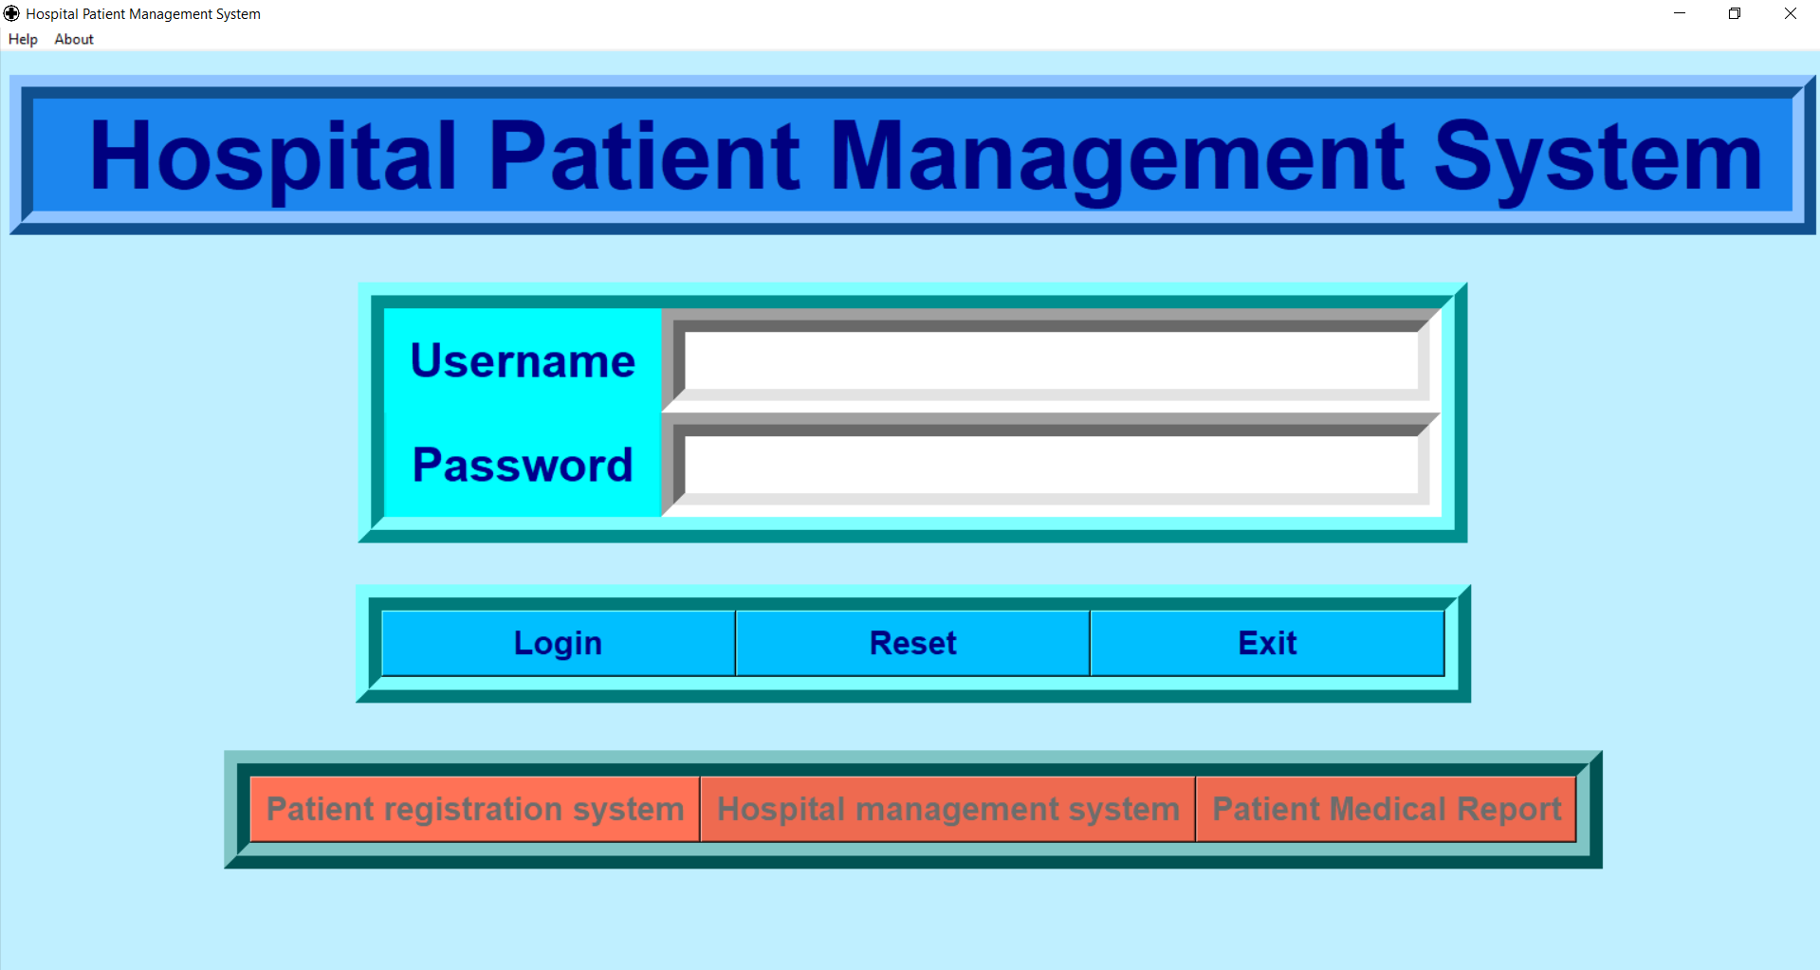

Fig 2. Patient Registration System
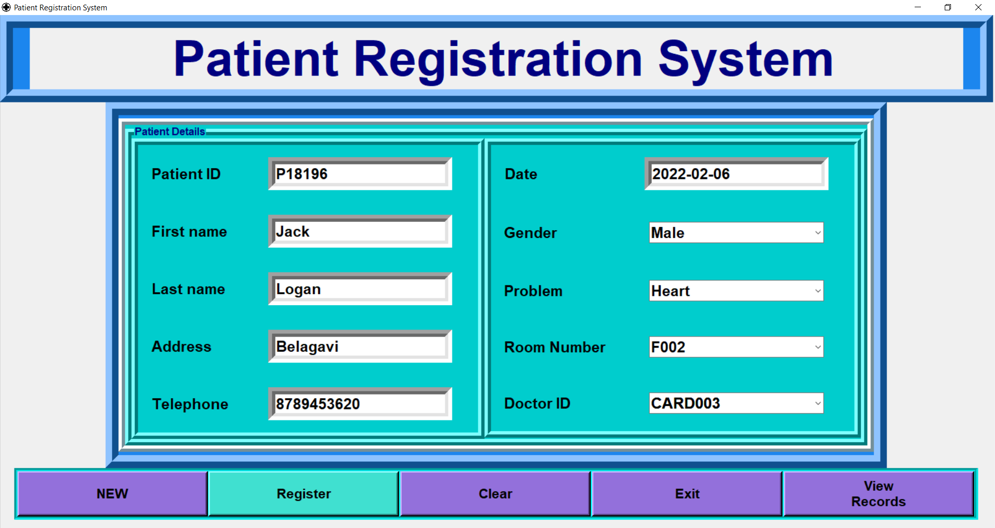
Fig 3. Patient Database
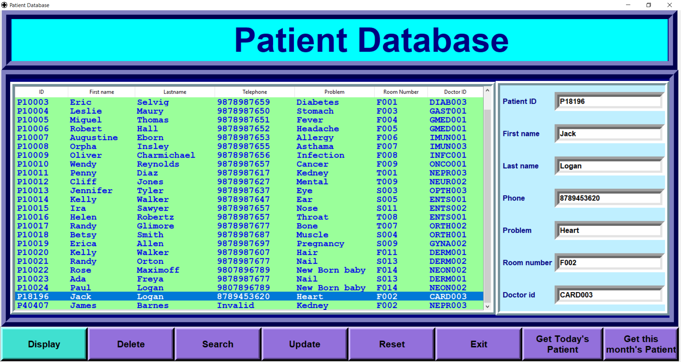

Fig 4. Patient Record Database
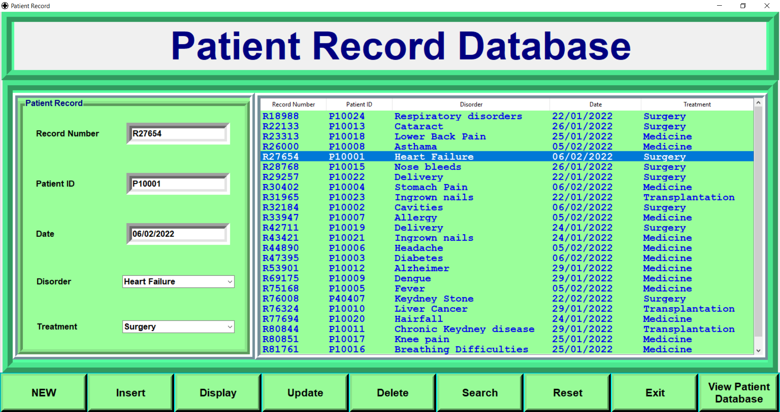
Fig 5. Hospital Management System
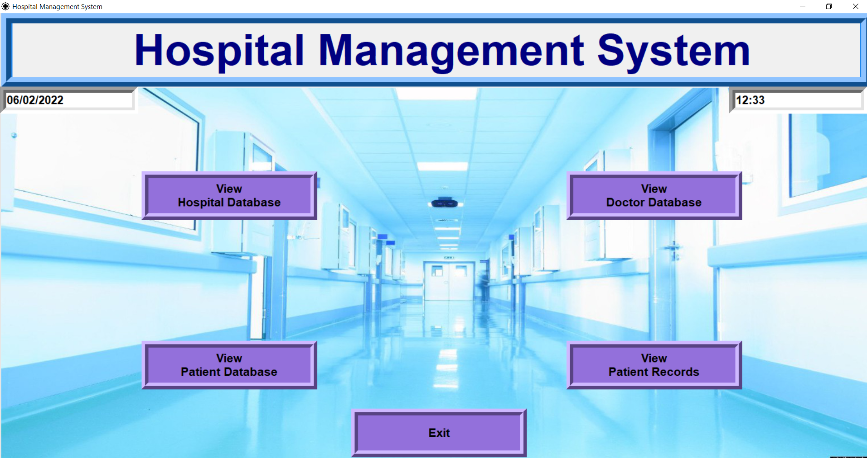

Fig 6. Hospital Database
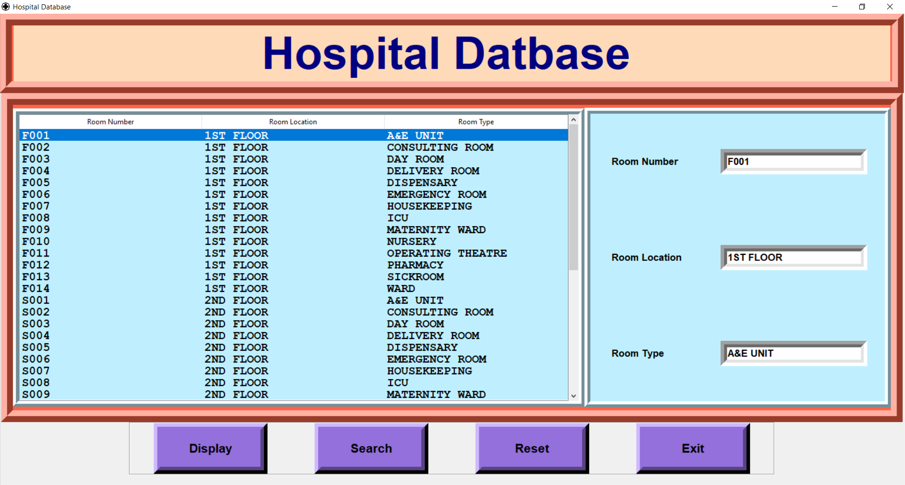
Fig 6. Doctor Database
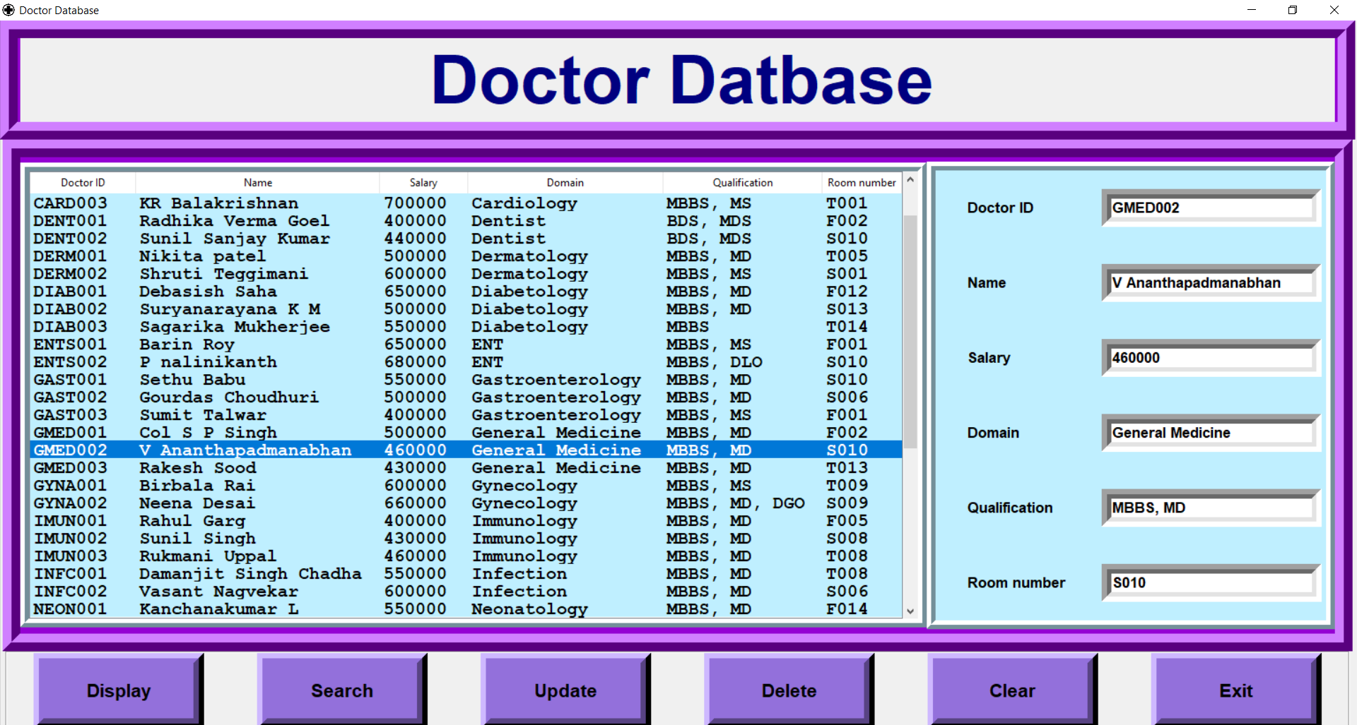

Conclusion:
The outcome of all the time, hard work is here. We have a system which registers the patients as well as maintains the hospital. This is achieved through user friendly graphical user interface. It gives appropriate access to authorized users only depending on their permissions. For large hospitals and health care centers, this automized system helps them to minimize the workload and provides instant services to patients.
The manual handling of the record is time consuming and highly prone to error. To improve the performance of the hospital management, the computerized hospital patient management system is to be undertaken. The fast-growing use of digitalized systems confirms the good feature and scope of the proposed project.

References:
https://docs.python.org/3/library/tkinter.html
https://pymysql.readthedocs.io/en/latest/
https://dev.mysql.com/doc/

